**Perspective Scenario Analysis**

**FIRST….a good reference chart.**

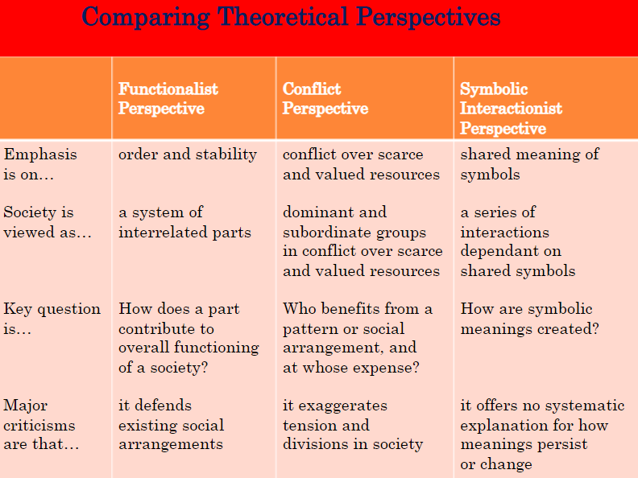

***Part 1: Provided Scenarios***

**Directions:** Read the following scenarios about political conflicts and questions below. ***Do not answer the question.***  *Instead, state which perspective would ask this type of question*. ***Explain your answer stating why you think this is the correct answer****.*

**Scenario 1**

*In September 2008, Thailand experienced protests in certain areas of Bangkok, its capital city. The protestors claimed that Prime Minister (PM) Samak’s leadership is not good for Thailand. They believed that PM Samak is too close to the former Prime Minister Thaksin. The protestors also claimed that PM Samak’s party was not elected fairly, but rather they bought votes to regain power. On the other side of the issue, supporters of PM Samak claimed that Samak can talk to whoever he wishes, even if he speaks with Thaksin. Samak’s party also claimed that they did not buy votes and were democratically elected by the people to lead the nation. Samuk’s followers usually dressed in yellow, yellow being the royal color in Thailand while supporters of the deposed prime minister Thaksin were widely called "red shirts".*

| *Question* | *Perspective* | *Explanation* |
| --- | --- | --- |
| What is the role of elections in the stability of society and government control? |  |  |
| How has the balance of power between the two parties led protests? |  |  |
| How did the pro-Samak protestors use the Royal Institution in Thailand to represent their stance? |  |  |

**Scenario 2**

*In recent years, the ongoing conflict between Israel and Hamas has escalated, resulting in significant violence in Gaza and surrounding areas. The conflict is rooted in longstanding territorial disputes, political tensions, and issues of sovereignty. Civilians in Gaza face severe humanitarian challenges, including limited access to resources, healthcare, and education. Supporters of Israel argue that its actions are necessary for security and self-defense against Hamas, a group designated as a terrorist organization by the United States and others. On the other hand, critics highlight the disproportionate impact on Palestinian civilians and call for addressing the root causes of the conflict. The international community is divided, with some nations backing Israel and others advocating for Palestinian rights and statehood.*

| *Question* | *Perspective* | *Explanation* |
| --- | --- | --- |
| What importance do terms like “self-defense” and “occupation” carry for Jewish and Muslim groups? |  |  |
| How does the ongoing conflict impact access to essential institutions like healthcare and education in Gaza? |  |  |
| How do power dynamics between Israel and Hamas contribute to the continuation of the conflict? |  |  |

**Scenario 3**

*In 2017, NFL players began kneeling during the national anthem as a form of protest against police brutality and racial injustice. The protest, initially started by quarterback Colin Kaepernick, sparked a nationwide debate. Supporters argued that the kneeling was a peaceful and powerful statement about systemic inequalities, while critics claimed it was disrespectful to the flag, the military, and American values. The controversy grew as President Trump and others publicly condemned the protests, while activists and civil rights groups rallied in support of the players. The issue extended beyond the NFL, with some high school and college teams joining the protests and others facing backlash from their communities.*

| *Question* | *Perspective* | *Explanation* |
| --- | --- | --- |
| How does the act of kneeling during the anthem challenge or support the stability of society and its institutions? |  |  |
| How do power dynamics between the NFL, players, and political leaders shape the conflict surrounding the protest? |  |  |
| What larger meaning does kneeling during the national anthem carry for different groups involved in the debate? |  |  |

***Part Two: Your Scenarios***

**Directions:**  Consider the three pictures below showing different forms of protest. Beside each photo, ***ask three questions that might be asked about the photo’s content.*** Each question should represent a different perspective.

| *Image* | *Functionalist* | *Conflict* | *Symbolic Interactionist* |
| --- | --- | --- | --- |
|  |  |  |  |
|  |  |  |  |
|  |  |  |  |

***Part Three: Choose your own image to analyze!***

**Directions:**  Pick a photo from the[2024 Time Magazine Top 100](https://time.com/7176286/top-100-photos-2024/) photos to analyze from the three perspectives. Include two insights that each would make about the events portrayed in your photo.

| Paste Image here: | Analyze from [a Functionalist Perspective](https://www.youtube.com/watch?v=-83vVeSC2_g) (What would they see, think, or wonder):  1.  2. |
| --- | --- |
| Analyze from [a Conflict Perspective](https://www.youtube.com/watch?v=LPYTndFFTko) (What would they see, think, or wonder):  1.  2. |
| Analyze from [a Symbolic Interactionist Perspective](https://www.youtube.com/watch?v=Ux2E6uhEVk0&t=1s) (What would they see, think, or wonder):  1.  2. |